**Exercise: Create an AWS Account**

*The exercises are designed to be completed in your AWS account, and* ***will have an associated cost.*** *For this reason, in addition to the written instructions, this course includes video recordings of the exercises. If you intend to attempt the exercises, familiarize yourself with* [*AWS pricing*](https://aws.amazon.com/pricing/)*, specifically* [*Amazon EC2 pricing*](https://aws.amazon.com/ec2/pricing/)*,* [*Amazon S3 pricing*](https://aws.amazon.com/s3/pricing/)*, and* [*Amazon DynamoDB pricing*](https://aws.amazon.com/dynamodb/pricing/) *and the* [*AWS Free Tier*](https://aws.amazon.com/free/)*.*

In this scenario, imagine you work for a company that currently has no presence in the cloud. You have been tasked with creating the companies employee directory application in AWS.

In this exercise, you will be creating and confirming a new AWS account. You will then log into that account and do basic management tasks, such as choosing a support plan.

**Lab Steps**

**Stage 1 - Sign up for an account**

1. Visit the [Amazon Web Services home page](https://aws.amazon.com/).
2. Choose **Create an AWS Account**. **Note:** If you signed in to AWS recently, choose **Sign in to the Console**. If **Create a new AWS account** isn't visible, first choose **Sign in to a different account**, and then choose **Create a new AWS account**.
3. Enter your account information, and then choose **Continue**. Be sure that you enter your account information correctly, especially your email address. If you enter your email address incorrectly, you can't access your account.
4. Choose **Personal** or **Professional**.

**Note:** These two account types are identical in functionality. You can choose a personal account for your personal projects or choose professional for use within your company, an educational institution, or an organization.

1. Enter your company or personal information.
2. Read the [AWS Customer Agreement](https://aws.amazon.com/agreement/), and then check the box.
3. Click **Create Account and Continue**.

**Stage 2 - Add a payment method**

1. On the **Payment Information** page, add a payment method by typing the requested information associated with your payment method.
2. Choose **Verify and Add**.

**Important:** You can't proceed with the sign-up process until you add a valid payment method.

**Stage 3 - Verify your identity**

1. On the **Identity Verification** page. Choose your country or region code from the list.
2. Enter a phone number where you can be reached in the next few minutes.
3. Enter the code displayed in the **CAPTCHA**.
4. When you're ready to receive a call or text message (sms). Choose **Contact me/Send SMS**. In a few moments you should be contacted via the verification system.
5. Enter the **verification code** you receive and choose **Verify Code**.
6. Choose **Continue**.

**Stage 4 - Choose an AWS Support plan**

1. On the **Select a Support Plan** page, select the **Basic Plan** included in the free tier.
2. Click **Sign in to Console** to sign in to your console.

**Stage 5 - Set up free tier alert and custom billing alert**

1. Search for **Billing** in the search bar and select it.
2. In the left hand navigation bar select **Billing preferences**
3. Under the **Cost Management Preferences** section, select the check boxes for **Receive Free Tier Usage Alerts** and **Receive Billing Alerts**.
4. Enter your email address into the text input box under **Receive Free Tier Usage Alerts**.
5. Select Save preferences.
6. In the services search bar, type in CloudWatch and select it.
7. If necessary, **change the Region** in the upper right corner to US East (N. Virginia). Billing metric data is stored in this Region and represents worldwide charges.
8. In the navigation pane, choose **Alarms**, then click **Create Alarm**.
9. Choose **Select metric**. In the search bar under Metrics, type in **Billing**, then choose **Billing >Total Estimated Charge**. *If you don't see Billing or the Total Estimated Charge metric, you may need to go back a few steps to enable billing alerts from the Billing preferences page.*
10. Select the check box next to **EstimatedCharges**, and choose **Select metric**.
11. Under **Conditions**, choose **Static**.
12. For Whenever EstimatedCharges is, choose **Greater**.
13. For than, enter the monthly amount (this should be whatever number you are comfortable with. For example, 10) that must be exceeded to trigger the alarm. Choose **Next**.
14. In the **Notification** box, for Alarm State Trigger, select **In alarm**. Under **Select an SNS Topic**, choose **create a new topic** to be notified.

*Amazon Simple Notification Service (Amazon SNS) is a service that publishes messages to a topic which delivers the message to all topic subscribers.*

1. **Enter a topic name**. The name must be unique. Then, type in your email to receive the notification.

*NOTE: You will get an email in your inbox asking you to confirm your subscription to this topic. By confirming, you're ensuring that you will get notifications when your estimated billing charges rises above your threshold.*

Click **Create Topic**. Then, select **Next**.

1. Enter in an alarm name and description. The name must contain only ASCII characters.
2. Under **Preview and create**, confirm that the information and conditions are what you want, then choose **Create alarm**.

**Lab Complete**

Congratulations! You have completed the lab.

<https://aws-tc-largeobjects.s3-us-west-2.amazonaws.com/DEV-AWS-MO-GCNv2/lab-2-iam.html>

[version_1.0]

©2021 Amazon Web Services, Inc. and its affiliates. All rights reserved. This work may not be reproduced or redistributed, in whole or in part, without prior written permission from Amazon Web Services, Inc. Commercial copying, lending, or selling is prohibited.

Errors or corrections? Contact us at <https://support.aws.amazon.com/#/contacts/aws-training>

# Exercise: Following IAM Best Practices

The exercises are designed to be completed in your AWS account, and ***will have an associated cost.*** For this reason, in addition to the written instructions, this course includes video recordings of the exercises. If you intend to attempt the exercises, familiarize yourself with [*AWS pricing*](https://aws.amazon.com/pricing/), specifically [*Amazon EC2 pricing*](https://aws.amazon.com/ec2/pricing/), [*Amazon S3 pricing*](https://aws.amazon.com/s3/pricing/), and [*Amazon DynamoDB pricing*](https://aws.amazon.com/dynamodb/pricing/) and the [*AWS Free Tier*](https://aws.amazon.com/free/).

In this scenario, you will follow best practices while continuing to set up your new AWS account. In this exercise, you will log into the root account, delete the root user access keys, and set up multi-factor authentication (MFA).

Instead of using the root user, you will create an IAM admin user. Then, you will will log in as the IAM admin user and create an IAM role that you will later assign to an EC2 instance hosting the employee directory application.

## Lab Steps

### Stage 1 - Login to the Console

1. Visit <https://aws.amazon.com/console/>
2. Choose **Sign In to the Console**.
3. Choose **Root user**. Enter the **Root user email address**.
4. Choose **Next**.
5. Enter the **Password** for the root user. Choose **Sign in**.

### Stage 2 - Enable MFA (optional)

1. At the top right, choose your **account name**. Then choose **My Security Credentials** from the drop down menu.
2. Expand **Multi-factor authentication (MFA)**. Choose **Activate MFA**.
3. On the **Manage MFA device** pop-up window. Choose **Virtual MFA device** and choose **Continue**.

**Note:** You will need a virtual MFA application installed on your device or computer. You can see a list of applications on step 1 on the **Set up virtual MFA device** pop-up window. There is a hyperlink which shows a [list of compatible applications](https://aws.amazon.com/iam/features/mfa/). Before continuing to the next step make sure you have one of these applications installed on your mobile device or computer.

1. Choose **Show QR code** and scan the code using your device.

**Note:** If you are using a computer you can choose **Show secret key** and type the secret key into your MFA application.

1. Type the first MFA code into the **MFA code 1** field. Then type the second generated number into the **MFA code 2** field. Choose **Assign MFA**.
2. You should see a pop-up indicating that you have successfully assigned a virtual MFA device. Choose **Close**.
3. Expand **Access keys (access key ID and secret access key)**.

**Note:** There should be no access keys listed. If an access key exists (for your new account) choose **Delete** under **Actions**. Choose **Deactivate**. Enter in the access key ID in the confirmation field. Choose **Delete**.

### Stage 3 - Create an IAM user

1. In the service search bar, type in **Identity and Access Management (IAM)** dashboard. On the left side panel, choose **Users**.
2. Choose **Add user**. Paste in Admin for the **User name**. Next to **Access type**, choose **Programmatic access** and **AWS Management Console access**.
3. Next to **Console password**, choose **Custom password** and type in a password of your choosing.
4. Uncheck **Require password reset**.
5. Choose **Next: Permissions**.
6. Choose **Attach existing policies directly**. Next to **Filter policies**, search for administrator. Under **Policy name**, choose **AdministratorAccess**. Choose **Next: Tags**.
7. Choose **Next: Review**. Choose **Create user**.
8. You can sign in with the new IAM user by clicking the hyperlink at the bottom of the **Success** window.

**Note:** It should look similar to the following: <https://000000000000.signin.aws.amazon.com/console>. Your account number will be different :)

1. Log in using the **Admin** user and password that you created.

### Stage 4 - Set up an IAM role for EC2 instance

1. Now that you are logged in as the Admin user, search for **IAM** again in the service search bar. On the left side panel, choose **Roles**. Then, choose **Create role**.
2. Choose **AWS service**. Choose **EC2**. Choose **Next: Permissions**.
3. Next to **Filter policies**, search for amazons3full and choose **AmazonS3FullAccess**.
4. Next to **Filter policies** search for amazondynamodb and choose **AmazonDynamoDBFullAccess**.
5. Choose **Next: Tags**. Choose **Next: Review**.
6. For **Role name** paste in S3DynamoDBFullAccessRole. Choose **Create role**.

**Note: Using full access policies are not something reccommended you should do in a production environment. We are using these policies as a proof of concept to get your demo up and running quickly. Once your Amazon S3 bucket and Amazon DynamoDB table are created, you can come back and modify this IAM Role to have more specific and restrictive permissions. More on this later.**

### Lab Complete

Congratulations! You have completed the lab.

For feedback, suggestions, or corrections, please contact us at:<https://support.aws.amazon.com/#/contacts/aws-training>

Architecture:

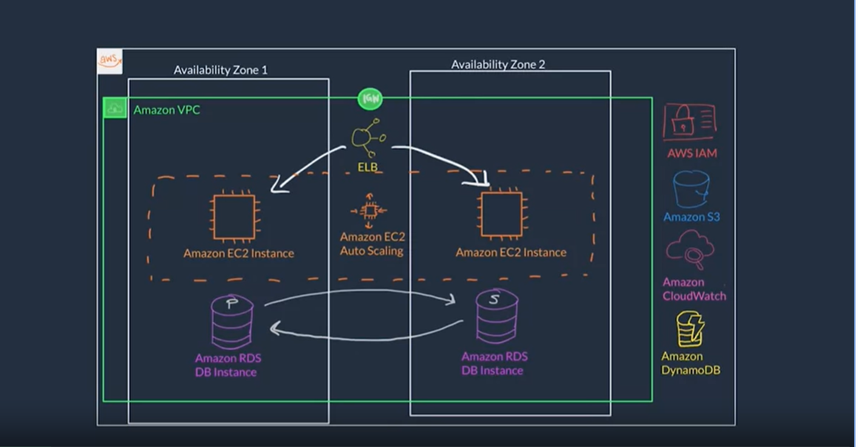

EC2 Instance lifecycle

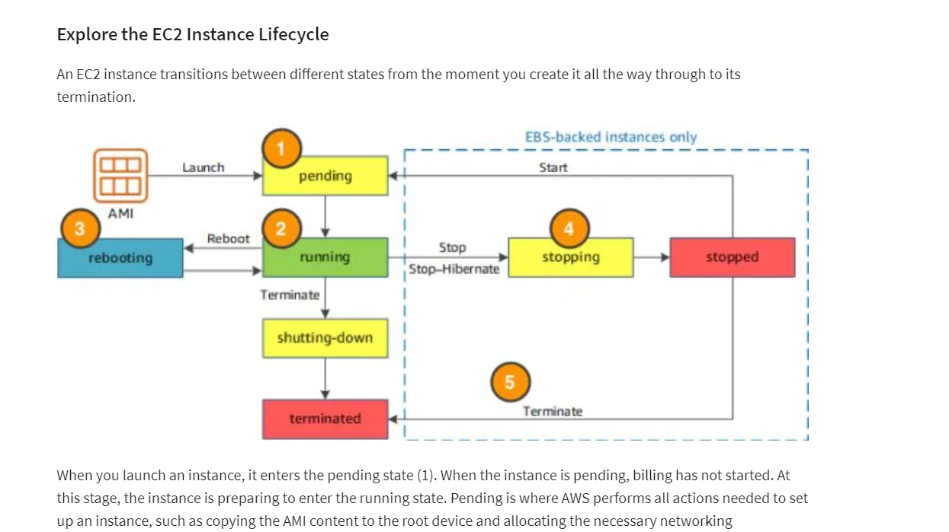

<https://aws-tc-largeobjects.s3-us-west-2.amazonaws.com/DEV-AWS-MO-GCNv2/lab-3-compute.html>

[version_1.0]

©2021 Amazon Web Services, Inc. and its affiliates. All rights reserved. This work may not be reproduced or redistributed, in whole or in part, without prior written permission from Amazon Web Services, Inc. Commercial copying, lending, or selling is prohibited.

Errors or corrections? Contact us at <https://support.aws.amazon.com/#/contacts/aws-training>

# Exercise: Compute

The exercises are designed to be completed in your AWS account, and ***will have an associated cost.*** For this reason, in addition to the written instructions, this course includes video recordings of the exercises. If you intend to attempt the exercises, familiarize yourself with [*AWS pricing*](https://aws.amazon.com/pricing/), specifically [*Amazon EC2 pricing*](https://aws.amazon.com/ec2/pricing/), [*Amazon S3 pricing*](https://aws.amazon.com/s3/pricing/), and [*Amazon DynamoDB pricing*](https://aws.amazon.com/dynamodb/pricing/) and the [*AWS Free Tier*](https://aws.amazon.com/free/).

For this scenario, you will be creating the employee directory application using user data configured during the EC2 instance set up. Since this is a dry run, you will terminate the instance afterwards to prevent additional costs from occuring.

In this exercise, you will log into the console as the IAM admin user. You will then launch an EC2 instance using the IAM role you created in the previous lab. Finally, once you've created the employee directory application, you will stop and then terminate the instance.

## Lab Steps

### Stage 1 - Launch EC2 instance using role

1. Search for **EC2** in the search bar at the top. Choose **EC2**.
2. Select **Instances** on the left side panel, and then choose the **Launch instance** button.
3. Choose **Select** next to the first AMI, which should be **Amazon Linux 2 AMI (HVM), SSD Volume Type**.
4. Choose the **t2.micro** (Free tier eligible) as the **Type**. Choose **Next: Configure Instance Details**.
5. Leave the **Network** as the (default). Next to **Subnet**, choose the first subnet in the drop down list.
6. Next to **Auto-assign Public IP** choose **Enable**.
7. Next to **IAM role** choose the **S3DynamoDBFullAccessRole**.
8. Scroll down to **Advanced Details**. Paste in the following into the **User data** box:



#!/bin/bash -ex

wget https://aws-tc-largeobjects.s3-us-west-2.amazonaws.com/DEV-AWS-MO-GCNv2/FlaskApp.zip

unzip FlaskApp.zip

cd FlaskApp/

yum -y install python3 mysql

pip3 install -r requirements.txt

amazon-linux-extras install epel

yum -y install stress

export PHOTOS_BUCKET=${SUB_PHOTOS_BUCKET}

export AWS_DEFAULT_REGION=<INSERT REGION HERE>

export DYNAMO_MODE=on

FLASK_APP=application.py /usr/local/bin/flask run --host=0.0.0.0 --port=80

Change the following line to match your region:

**Note:** You can find this at the top right next to your user name.



export AWS_DEFAULT_REGION=<INSERT REGION HERE>

Example:

**Note:** US West (Oregon)



export AWS_DEFAULT_REGION=us-west-2

**Note:** You will modify this User Data script again to use your Amazon S3 bucket in a later lab. For now, just leave the ${SUB_PHOTOS_BUCKET} in the script.

1. Choose **Next: Add Storage**. Choose **Next: Add Tags**.
2. Choose **Add Tag**. Under **Key** paste in Name. Under **Value** paste in employee-directory-app.
3. Choose **Next: Configure Security Group**. For **Security group name:** paste in app-sg.
4. Choose **Add Rule**. For **Type** choose **HTTP**. For **Source** change to **Anywhere**. Then, next to the **SSH** rule, choose the **X** at the right to remove it as you will not need SSH access to the instance.

Note: You may get a warning that you will no longer be able to SSH into your instance. This is fine - as you won't need that functionality for this course.

1. Choose **Review and Launch**. Choose **Launch**. Choose **Create a new key pair**. Under **Key pair name** paste in app-key-pair. Choose **Download Key Pair**. Finally choose **Launch instances**.
2. Scroll down, and choose **View Instances**. The instance should now show up under **Instances**. Wait for the **Instance state** to change to **Running** and the **Status check** to change to **2/2 checks passed**.

Note: Often, the status checks update and the UI does not. Feel free to refresh the page after a few minutes to minimize waiting.

1. Next to **Name**, choose the checkbox to select the instance. Under the **Details** tab, copy down the **Public IPv4 address**.

Note: do not click the link to open the IPv4 address. Simply just copy the address and paste it into a new tab.

1. Paste it into a new browser tab/window. You should see a **Employee Directory** placeholder. Right now you will not be able to interact with it as it's not currently connected to our DynamoDB database.

Congrats! You've successfully created an EC2 instance hosting the employee directory application. After you've finished looking around, it's time to stop and terminate your instance, so that you don't incur future costs.

1. Back in the AWS Management Console, the employee-directory-app should still be selected. Now, choose **Instance state** at the top and choose **Stop instance**. Choose **Stop**. The **Instance state** will eventually go into the **Stopped** state.
2. Next, you will terminate the instance. Again, select the checkbox next to the instance **Name**. Choose **Instance state** and choose **Terminate instance**. Choose **Terminate**.

### Lab Complete

Congratulations! You have completed the lab.

For feedback, suggestions, or corrections, please contact us at:<https://support.aws.amazon.com/#/contacts/aws-training>

CIDR

<https://www.ionos.com/digitalguide/server/know-how/cidr-classless-inter-domain-routing/>

<https://web.stanford.edu/class/cs101/network-1-introduction.html>

# Exercise: Compute & Networking

<https://aws-tc-largeobjects.s3-us-west-2.amazonaws.com/DEV-AWS-MO-GCNv2/lab-4-networking.html>

[version_1.0]

©2021 Amazon Web Services, Inc. and its affiliates. All rights reserved. This work may not be reproduced or redistributed, in whole or in part, without prior written permission from Amazon Web Services, Inc. Commercial copying, lending, or selling is prohibited.

Errors or corrections? Contact us at <https://support.aws.amazon.com/#/contacts/aws-training>

# Exercise: Compute & Networking

The exercises are designed to be completed in your AWS account, and ***will have an associated cost.*** For this reason, in addition to the written instructions, this course includes video recordings of the exercises. If you intend to attempt the exercises, familiarize yourself with [*AWS pricing*](https://aws.amazon.com/pricing/), specifically [*Amazon EC2 pricing*](https://aws.amazon.com/ec2/pricing/), [*Amazon S3 pricing*](https://aws.amazon.com/s3/pricing/), and [*Amazon DynamoDB pricing*](https://aws.amazon.com/dynamodb/pricing/) and the [*AWS Free Tier*](https://aws.amazon.com/free/).

In this scenario, you will create the underlying network infrastructure in which the employee directory EC2 instance will live. In this exercise, you will set up a new VPC with four subnets (two public and two private) and two route tables (one public and one private). Then, you will launch an EC2 instance inside the new VPC. Finally, at the end of the lab, you will stop the instance to prevent future costs from incurring.

## Lab Steps

### Stage 1 - Create VPC

1. Search for **VPC** in the search bar at the top. Choose **VPC**.
2. Choose **Your VPCs** in the left panel. Choose **Create VPC**. Under **Name tag** paste in app-vpc.
3. For the **IPv4 CIDR block** paste in 10.1.0.0/16. Choose **Create VPC**.
4. Choose **Internet Gateways** in the left panel. Choose **Create internet gateway**. Under **Name tag** paste in app-igw. Choose **Create internet gateway**.
5. Choose **Actions** and **Attach to VPC**. Under **Available VPCs** choose the app-vpc. Choose **Attach internet gateway**.

### Stage 2 - Create Subnets

1. Choose **Subnets** at the left. Choose **Create subnet**. Under **VPC ID**, select the app-vpc from the drop down list.
2. Under **Subnet settings** and **Subnet name**, paste in Public Subnet 1. Under **Availability Zone**, choose the 1st AZ.

Example: If you are in US West (Oregon) you would choose **us-west-2a**.

1. For the **IPv4 CIDR block** paste in 10.1.1.0/24.
2. Choose **Add new subnet**. Under **Subnet name**, paste in Public Subnet 2. Under **Availability Zone**, choose the 2nd AZ.

Example: If you are in US West (Oregon) you would choose **us-west-2b**.

1. For the **IPv4 CIDR block** paste in 10.1.2.0/24.
2. Choose **Add new subnet**. Under **Subnet name**, paste in Private Subnet 1. Under **Availability Zone,** choose the 1st AZ.

Example: If you are in US West (Oregon) you would choose **us-west-2a**.

1. For the **IPv4 CIDR block** paste in 10.1.3.0/24.
2. Choose **Add new subnet**. Under **Subnet name**, paste in Private Subnet 2. Under **Availability Zone**, choose the 2nd AZ.

Example: If you are in US West (Oregon) you would choose **us-west-2b**.

1. For the **IPv4 CIDR block** paste in 10.1.4.0/24.
2. Finally choose **Create subnet**.
3. Select the checkbox next to **Public Subnet 1** after the subnets have been created. Choose **Actions** and **Modify auto-assign IP settings**. Under **Auto-assign IPv4**, choose **Enable auto-assign public IPv4 address**. Choose **Save**.
4. De-select **Public Subnet 1**. Select the checkbox next to **Public Subnet 2**. Choose **Actions** and **Modify auto-assign IP settings**. Under **Auto-assign IPv4**, choose **Enable auto-assign public IPv4 address**. Choose **Save**.

### Stage 3 - Create Route Tables

1. Choose **Route Tables** at the left. Choose **Create route table**. Under **Name tag**, paste in app-routetable-public. Under **VPC**, choose the app-vpc. Choose **Create**. Choose **Close**.
2. Select the app-routetable-public from the list. Choose the **Routes** tab. Choose **Edit routes**.
3. Choose **Add route**. For **Destination**, paste in 0.0.0.0/0. For **Target** choose **Internet Gateway**. Choose the app-igw you set up in the VPC section. Select **Save routes**. Choose **Close**.
4. Choose the **Subnet Associations** tab. Choose **Edit subnet associations**. Select the 2 Public subnets (Public Subnet 1 & Public Subnet 2) you created in the Subnet section. Choose **Save**.
5. Choose **Create route table**. Under **Name tag** paste in app-routetable-private. Under **VPC** chose the app-vpc. Choose **Create**. Choose **Close**.
6. Deselect the app-routetable-public. Select the app-routetable-private from the list. Choose the **Subnet Associations** tab. Choose **Edit subnet associations**. Select the 2 Private subnets (Private Subnet 1 & Private Subnet 2) you created in the Subnet section. Choose **Save**.

### Stage 4 - Launch EC2 instances using role

Now that you've created a network, it's time to launch your EC2 instance using the VPC you created!

1. Search for **EC2** in the search bar at the top. Choose **EC2**.
2. Under **Launch instance** choose the **Launch instance** button.
3. Choose **Select** next to the first AMI which should be **Amazon Linux 2 AMI (HVM), SSD Volume Type**.
4. Choose the **t2.micro** (Free tier eligible) as the **Type**. Choose **Next: Configure Instance Details**.
5. Next to **Network** choose the app-vpc from the list. Next to **Subnet** choose Public Subnet 1 from the list.
6. Next to **Auto-assign Public IP** choose **Enable**.
7. Next to **IAM role** choose the **S3DynamoDBFullAccessRole**.
8. Scroll down to **Advanced Details**. Paste in the following into the **User data** box:



#!/bin/bash -ex

wget https://aws-tc-largeobjects.s3-us-west-2.amazonaws.com/DEV-AWS-MO-GCNv2/FlaskApp.zip

unzip FlaskApp.zip

cd FlaskApp/

yum -y install python3 mysql

pip3 install -r requirements.txt

amazon-linux-extras install epel

yum -y install stress

export PHOTOS_BUCKET=${SUB_PHOTOS_BUCKET}

export AWS_DEFAULT_REGION=<INSERT REGION HERE>

export DYNAMO_MODE=on

FLASK_APP=application.py /usr/local/bin/flask run --host=0.0.0.0 --port=80

Change the following line to match your region:

**Note:** You can find this at the top right next to your user name.



export AWS_DEFAULT_REGION=<INSERT REGION HERE>

Example:

**Note:** US West (Oregon)



export AWS_DEFAULT_REGION=us-west-2

**Note:** You still do not have to change the PHOTOS_BUCKET variable in the User Data script, you will do this in a later lab.

1. Choose **Next: Add Storage**. Choose **Next: Add Tags**.
2. Choose **Add Tag**. Under **Key** paste in Name. Under **Value** paste in employee-directory-app.
3. Choose **Next: Configure Security Group**. For **Security group name:** paste in web-security-group.
4. For the **Description** paste in Enable HTTP access.
5. Choose **Add Rule**. For **Type**, choose **HTTP**. For **Source**, change to **Anywhere**. Choose **Add Rule**. For **Type**, choose **HTTPS**. For **Source**, change to **Anywhere**. Then, next to the **SSH** rule, choose the **X** at the right to remove it as you will not need SSH access to the instance.
6. Choose **Review and Launch**. Choose **Launch**. Leave **Choose an existing key pair** selected. Under **Select a key pair** app-key-pair should be selected. Select the checkbox next to the acknowledgement. Choose **Launch Instances**.
7. Choose **View Instances**. The instance should now show up under **Instances**. Wait for the **Instance state** to change to **Running** and the **Status check** to change to **2/2 checks passed**.

Note: Often, the status checks update and the UI does not. Feel free to refresh the page after a few minutes to minimize waiting.

1. Next to **Name**, choose the checkbox to select the running employee-directory-app instance. Under the **Details** tab, copy down the **Public IPv4 address**.

Note: do not click the link to open the IPv4 address. Simply just copy the address and paste it into a new tab.

1. Paste it into a new browser tab/window. You should see a **Employee Directory** placeholder. Right now, you will not be able to interact with it as it's not currently connected to a database.

### Stage 5 - Stop instance

Congrats! You've launched an EC2 instance hosting your employee directory application into a customized VPC. To prevent future costs, you will now stop the instance. (Note: do not terminate it, as the next lab will use this instance.)

1. Choose **Instance state** and **Stop instance**. Choose **Stop**. The **Instance state** will eventually go into the **Stopped** state.

### Lab Complete

Congratulations! You have completed the lab.

For feedback, suggestions, or corrections, please contact us at:<https://support.aws.amazon.com/#/contacts/aws-training>

